EXPERIMENT 6 B

DATA VISUALIZATION USING POWER BI – Retail / Sales Dataset

Aim
To import, transform, analyze, and visualize the transaction dataset using Power BI Desktop and create an interactive dashboard.

Algorithm 1 – Importing Data into Power BI
Step 1 Open Power BI Desktop.
Step 2 Select Home → Get Data → Text/CSV.
Step 3 Browse and select your transaction CSV dataset.
Step 4 Click Load.
Step 5 Verify the imported data.
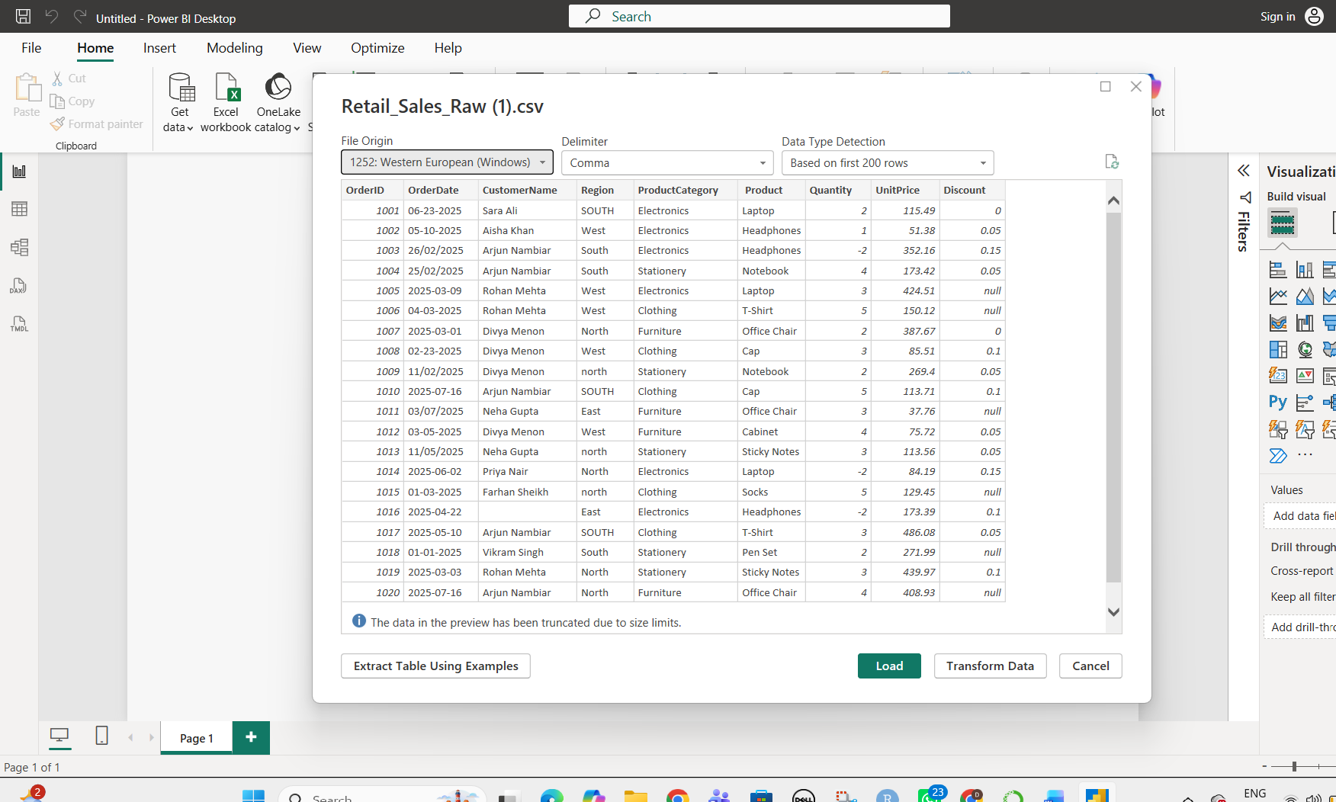

Algorithm 2 – Data Transformation
Step 1 Select Transform Data.
Step 2 Open Power Query Editor.
Step 3 Remove duplicate records.
Step 4 Check for missing values.
Step 5 Check and correct data types.
Step 6 Click Close & Apply.
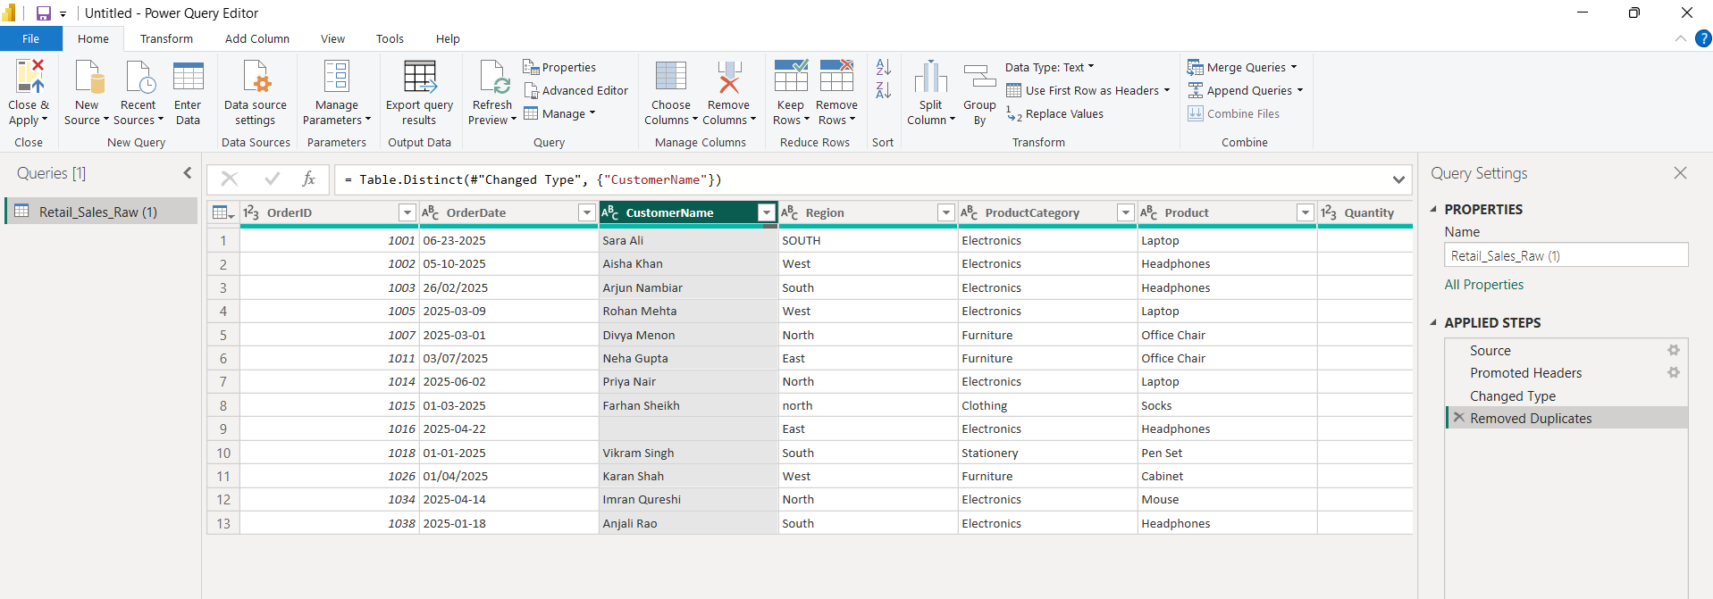

Algorithm 3 – Creating a Bar Chart
Step 1 Select Clustered Column Chart.
Step 2 Drag ProductCategory → X-axis.
Step 3 Drag Quantity → Y-axis.
Step 4 Apply formatting.

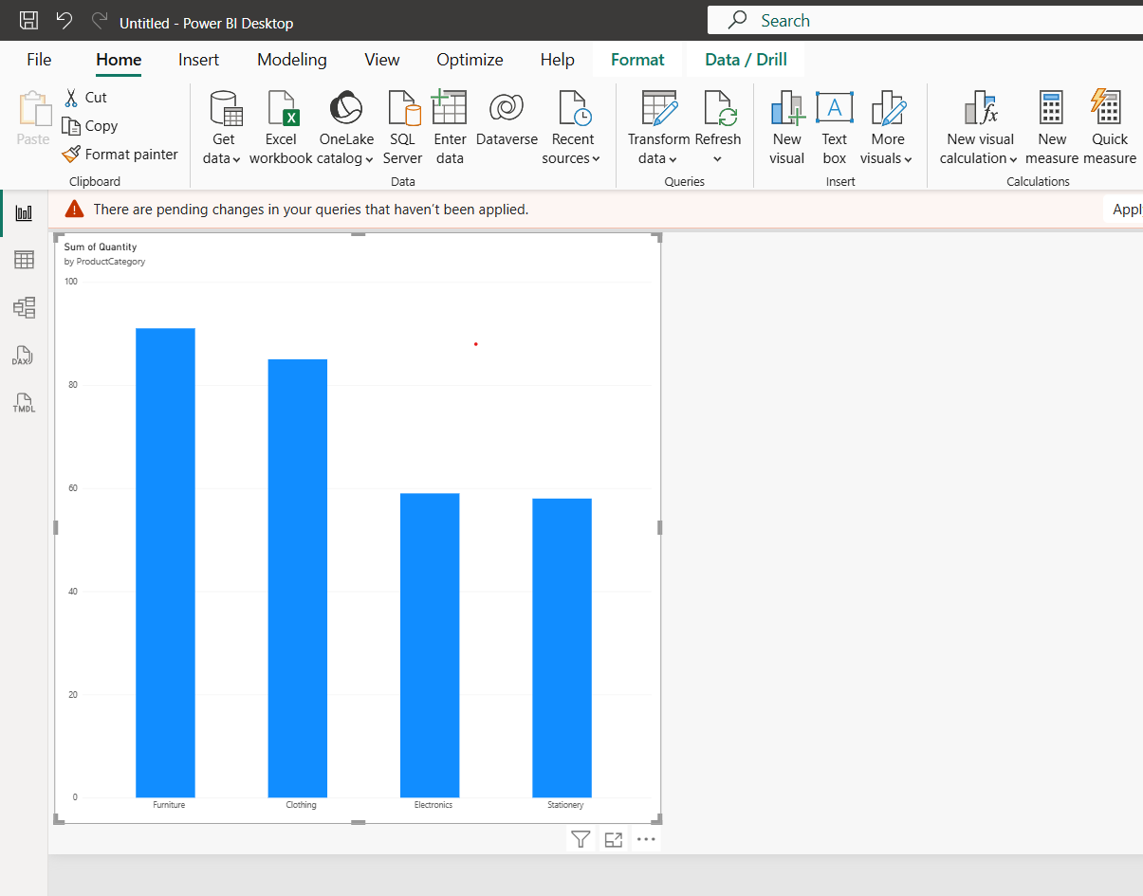

Algorithm 4 – Creating a Pie Chart
Step 1 Select Pie Chart.
Step 2 Drag Region → Legend.
Step 3 Drag OrderID → Values.
Step 4 Set OrderID aggregation to Count.
Step 5 Enable data labels.

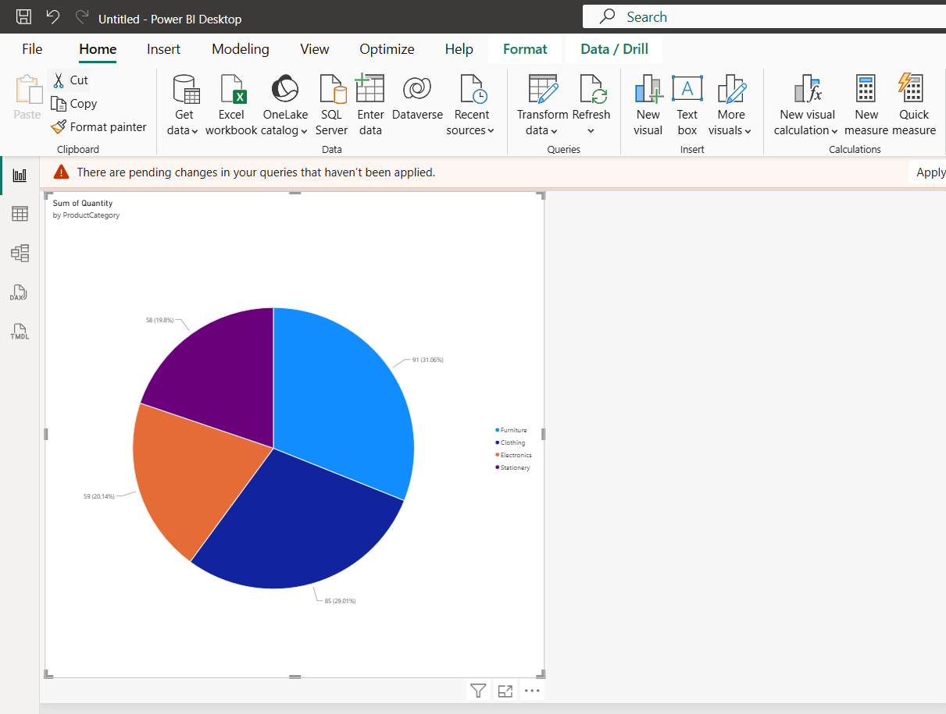

Algorithm 5 – Creating a KPI Card
Step 1 Select Card visualization.
Step 2 Drag UnitPrice → Values.
Step 3 Set aggregation as Average.

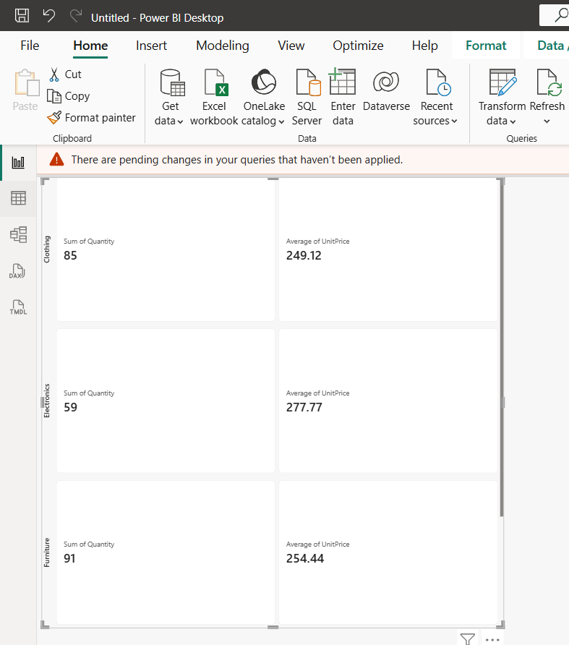

Result
Thus, the transaction dataset was successfully imported, transformed, analyzed, and visualized in Power BI using bar charts, pie charts, KPI cards, slicers, DAX measures, and an interactive dashboard.

